Flex Box layout
CSS 2 defined four layout modes — algorithms which determine the size and position of boxes based on their relationships with their sibling and ancestor boxes:

- block layout, designed for laying out documents

- inline layout, designed for laying out text

- table layout, designed for laying out 2D data in a tabular format

- positioned layout, designed for very explicit positioning without much regard for other elements in the document

CSS3 module introduces a new layout mode, flex layout

Flex layout is superficially similar to block layout. It lacks many of the more complex text- or document-centric properties that can be used in block layout, such as floats and columns. In return it gains simple and powerful tools for distributing space and aligning content in ways that web apps and complex web pages often need.

The contents of a flex container:
can be laid out in any flow direction (leftwards, rightwards, downwards, or even upwards!)
can have their display order reversed or rearranged at the style layer
can be laid out linearly along a single (main) axis or wrapped into multiple lines along a secondary (cross) axis
can “flex” their sizes to respond to the available space
can be aligned with respect to their container or each other on the secondary (cross)
can be dynamically collapsed or uncollapsed along the main axis while preserving the container’s cross size

Flex Layout Box Model and Terminology
A flex container is the box generated by an element with a computed display of flex or inline-flex. In-flow children of a flex container are called flex items and are laid out using the flex layout model.

Unlike block and inline layout, whose layout calculations are biased to the block and inline flow directions, flex layout is biased to the flex directions. To make it easier to talk about flex layout,
We have set of flex flow–relative terms.
The flex-flow value and the writing mode determine how these terms map to physical directions (top/right/bottom/left), axes (vertical/horizontal), and sizes (width/height).

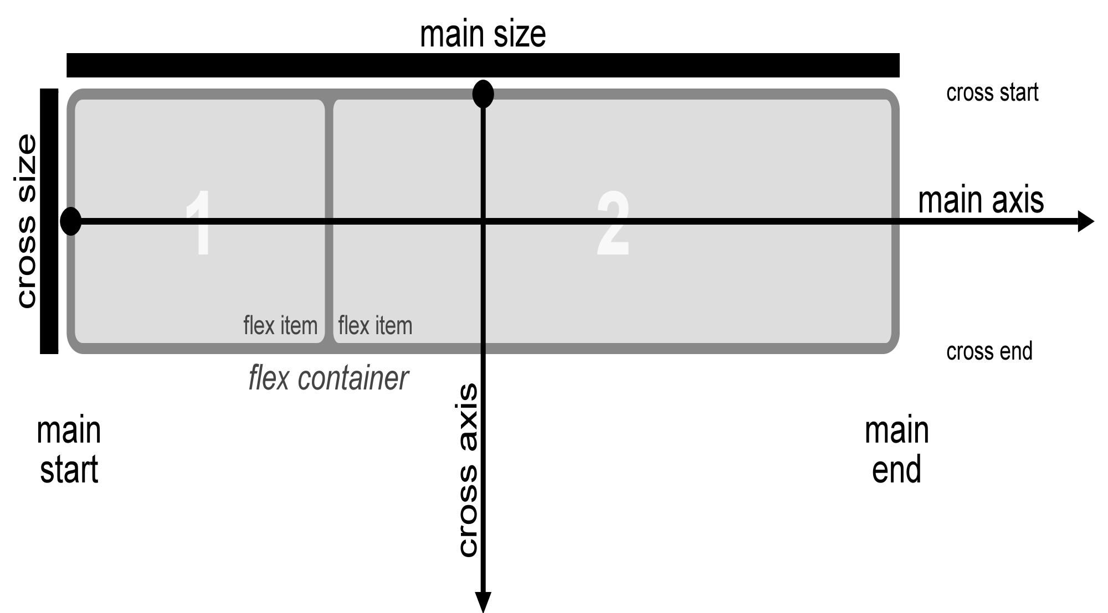
An illustration of the various directions and sizing terms as applied to a row flex container.
main axis
main dimension
The main axis of a flex container is the primary axis along which flex items are laid out. It extends in the main dimension.

main-start
main-end
The flex items are placed within the container starting on the main-start side and going toward the main-end side.

main size
main size property
The width or height of a flex container or flex item, whichever is in the main dimension, is that box’s main size. Its main size property is thus either its width or height property, whichever is in the main dimension. Similarly, its min and max main size properties are its min-width/max-width or min-height/max-height properties, whichever is in the main dimension, and determine its min/max main size.

cross axis
cross dimension
The axis perpendicular to the main axis is called the cross axis. It extends in the cross dimension.

cross-start
cross-end
Flex lines are filled with items and placed into the container starting on the cross-start side of the flex container and going toward the cross-end side.

cross size
cross size property
The width or height of a flex container or flex item, whichever is in the cross dimension, is that box’s cross size. Its cross size property is thus either its width or height property, whichever is in the cross dimension. Similarly, its min and max cross size properties are its min-width/max-width or min-height/max-height properties, whichever is in the cross dimension, and determine its min/max cross size.

Flex Containers: the flex and inline-flex display values

To set the flex container we set its display property to either of the two:

flex
This value causes an element to generate a flex container box that is block-level when placed in flow layout.
inline-flex
This value causes an element to generate a flex container box that is inline-level when placed in flow layout.

A flex container establishes a new flex formatting context for its contents. This is the same as establishing a block formatting context, except that flex layout is used instead of block layout. For example, floats do not intrude into the flex container, and the flex container’s margins do not collapse with the margins of its contents. Flex containers form a containing block for their contents exactly like block containers do.
The overflow property applies to flex containers.

Flex containers are not block containers, and so some properties that were designed with the assumption of block layout don’t apply in the context of flex layout. In particular:
float and clear do not create floating or clearance of flex item, and do not take it out-of-flow.
vertical-align has no effect on a flex item.
the ::first-line and ::first-letter pseudo-elements do not apply to flex containers, and flex containers do not contribute a first formatted line or first letter to their ancestors.

Flex Items
Loosely speaking, the flex items of a flex container are boxes representing its in-flow contents.

Each in-flow child of a flex container becomes a flex item, and each contiguous sequence of child text runs is wrapped in an anonymous block container flex item. However, if the entire sequence of child text runs contains only white space (i.e. characters that can be affected by the white-space property) it is instead not rendered (just as if its text nodes were display:none).

Absolutely-Positioned Flex Children

As it is out-of-flow, an absolutely-positioned child of a flex container does not participate in flex layout.

The static position of an absolutely-positioned child of a flex container is determined such that the child is positioned as if it were the sole flex item in the flex container, assuming both the child and the flex container were fixed-size boxes of their used size. For this purpose, auto margins are treated as zero.

Flex Item Margins and Paddings
The margins of adjacent flex items do not collapse.

Percentage margins and paddings on flex items, like those on block boxes, are resolved against the inline size of their containing block, e.g. left/right/top/bottom percentages all resolve against their containing block’s width in horizontal writing modes.

Auto margins expand to absorb extra space in the corresponding dimension. They can be used for alignment, or to push adjacent flex items apart.

Flex Item Z-Ordering
Flex items paint exactly the same as inline blocks, except that order-modified document order is used in place of raw document order, and z-index values other than auto create a stacking context even if position is static (behaving exactly as if position were relative).

Collapsed Items
Specifying visibility:collapse on a flex item causes it to become a collapsed flex item, producing an effect similar to visibility:collapse on a table-row or table-column: the collapsed flex item is removed from rendering entirely, but leaves behind a "strut" that keeps the flex line’s cross-size stable. Thus, if a flex container has only one flex line, dynamically collapsing or uncollapsing items may change the flex container’s main size, but is guaranteed to have no effect on its cross size and won’t cause the rest of the page’s layout to "wobble". Flex line wrapping is re-done after collapsing, however, so the cross-size of a flex container with multiple lines might or might not change

The Automatic Minimum Size of Flex Items

A flex item cannot be smaller than the size of its content along the main axis.

The defaults are...

min-width: auto
min-height: auto
...for flex items in row-direction and column-direction, respectively.

You can override these defaults by setting flex items to:

min-width: 0
min-height: 0
overflow: hidden (or any other value, except visible)

To provide a more reasonable default minimum size for flex items, this specification introduces a new auto value as the initial value of the min-width and min-height properties defined in CSS 2.1.

With regard to the auto value...

On a flex item whose overflow is visible in the main axis, when specified on the flex item’s main-axis min-size property, specifies an automatic minimum size. It otherwise computes to 0.

In other words:

The min-width: auto and min-height: auto defaults apply only when overflow is visible.
If the overflow value is not visible, the value of the min-size property is 0.
Hence, overflow: hidden can be a substitute for min-width: 0 and min-height: 0.
and...

The minimum sizing algorithm applies only on the main axis.
For example, a flex item in a row-direction container does not get min-height: auto by default.

Ordering and Orientation
The contents of a flex container can be laid out in any direction and in any order. This functionality is exposed through the flex-direction, flex-wrap, and order properties

Flex Flow Direction: the flex-direction property
Name: | flex-direction
Value: | row | row-reverse | column | column-reverse
Initial: | row
Applies to: | flex containers
Inherited: | no
Percentages: | n/a
Computed value: | specified keyword
Canonical order: | per grammar
Animation type: | discrete

The flex-direction property specifies how flex items are placed in the flex container, by setting the direction of the flex container’s main axis. This determines the direction in which flex items are laid out.
row
The flex container’s main axis has the same orientation as the inline axis of the current writing mode. The main-start and main-end directions are equivalent to the inline-start and inline-end directions, respectively, of the current writing mode.
row-reverse
Same as row, except the main-start and main-end directions are swapped.
column
The flex container’s main axis has the same orientation as the block axis of the current writing mode. The main-start and main-end directions are equivalent to the block-start and block-end directions, respectively, of the current writing mode.
column-reverse
Same as column, except the main-start and main-end directions are swapped.

Flex Line Wrapping: the flex-wrap property
Name: | flex-wrap
Value: | nowrap | wrap | wrap-reverse
Initial: | nowrap
Applies to: | flex containers
Inherited: | no
Percentages: | n/a
Computed value: | specified keyword
Canonical order: | per grammar
Animation type: | discrete

The flex-wrap property controls whether the flex container is single-line or multi-line, and the direction of the cross-axis, which determines the direction new lines are stacked in.
nowrap
The flex container is single-line.
wrap
The flex container is multi-line.
wrap-reverse
Same as wrap.
For the values that are not wrap-reverse, the cross-start direction is equivalent to either the inline-start or block-start direction of the current writing mode (whichever is in the cross axis) and the cross-end direction is the opposite direction of cross-start. When flex-wrap is wrap-reverse, the cross-start and cross-end directions are swapped.

Flex Direction and Wrap: the flex-flow shorthand
Name: | flex-flow
Value: | <‘flex-direction’> || <‘flex-wrap’>
Initial: | see individual properties
Applies to: | see individual properties
Inherited: | see individual properties
Percentages: | see individual properties
Computed value: | see individual properties
Animation type: | see individual properties
Canonical order: | per grammar
The flex-flow property is a shorthand for setting the flex-direction and flex-wrap properties, which together define the flex container’s main and cross axes.

Display Order: the order property
Flex items are, by default, displayed and laid out in the same order as they appear in the source document. The order property can be used to change this ordering.
Name: | order
Value: | <integer>
Initial: | 0
Applies to: | flex items
Inherited: | no
Percentages: | n/a
Computed value: | specified integer
Canonical order: | per grammar
Animation type: | by computed value type

The order property controls the order in which flex items appear within the flex container, by assigning them to ordinal groups. It takes a single <integer> value, which specifies which ordinal group the flex item belongs to.

A flex container lays out its content in order-modified document order, starting from the lowest numbered ordinal group and going up. Items with the same ordinal group are laid out in the order they appear in the source document. This also affects the painting order [CSS21], exactly as if the flex items were reordered in the source document. Absolutely-positioned children of a flex container are treated as having order: 0 for the purpose of determining their painting order relative to flex items.
As an example, I have 5 flex items, and assign order values as follows:

Source item 1: order: 2
Source item 2: order: 3
Source item 3: order: 1
Source item 4: order: 3
Source item 5: order: 1
These items would be displayed on the page in the following order:

Source item 3: order: 1
Source item 5: order: 1
Source item 1: order: 2
Source item 2: order: 3
Source item 4: order: 3
Items have a number showing their source order which has been rearranged.


Flex items have a default order value of 0, therefore items with an integer value greater than 0 will be displayed after any items that have not been given an explicit order value.

We can also use negative values with order, which can be quite useful. If you want to make one item display first and leave the order of all other items unchanged, we can give that item order of -1. As this is lower than 0 the item will always be displayed first.

Flex Lines
Flex items in a flex container are laid out and aligned within flex lines, hypothetical containers used for grouping and alignment by the layout algorithm. A flex container can be either single-line or multi-line, depending on the flex-wrap property:

A single-line flex container (i.e. one with flex-wrap: nowrap) lays out all of its children in a single line, even if that would cause its contents to overflow.

A multi-line flex container (i.e. one with flex-wrap: wrap or flex-wrap: wrap-reverse) breaks its flex items across multiple lines, similar to how text is broken onto a new line when it gets too wide to fit on the existing line. When additional lines are created, they are stacked in the flex container along the cross axis according to the flex-wrap property. Every line contains at least one flex item, unless the flex container itself is completely empty.

Flexibility

The defining aspect of flex layout is the ability to make the flex items “flex”, altering their width/height to fill the available space in the main dimension. This is done with the flex property. A flex container distributes free space to its items (proportional to their flex grow factor) to fill the container, or shrinks them (proportional to their flex shrink factor) to prevent overflow.

A flex item is fully inflexible if both its flex-grow and flex-shrink values are zero, and flexible otherwise.

The flex Shorthand
Name: | flex
Value: | none | [ <‘flex-grow’> <‘flex-shrink’>? || <‘flex-basis’> ]
Initial: | 0 1 auto
Applies to: | flex items
Inherited: | no
Percentages: | see individual properties
Computed value: | see individual properties
Animation type: | by computed value type
Canonical order: | per grammar

The flex property is a sub-property of the Flexible Box Layout module.

This is the shorthand for flex-grow, flex-shrink and flex-basis. The second and third parameters (flex-shrink and flex-basis) are optional.
When a box is a flex item (ie its inside a flex container), flex is consulted instead of the main size property to determine the main size of the box. If a box is not a flex item, flex has no effect.
<‘flex-grow’>
Number,
Flex grow factor, which determines how much the flex item will grow relative to the rest of the flex items in the flex container when positive free space is distributed. When omitted, it is set to 1.
Flex values between 0 and 1 have a somewhat special behavior: when the sum of the flex values on the line is less than 1, they will take up less than 100% of the free space.
<‘flex-shrink’>
Number
Flex shrink factor, which determines how much the flex item will shrink relative to the rest of the flex items in the flex container when negative free space is distributed. When omitted, it is set to 1.
The flex shrink factor is multiplied by the flex base size when distributing negative space. This distributes negative space in proportion to how much the item is able to shrink, so that e.g. a small item won’t shrink to zero before a larger item has been noticeably reduced.
<‘flex-basis’>
The flex-basis property is a sub-property of the Flexible Box Layout module. It specifies the initial size of the flex item, before any available space is distributed according to the flex factors. When omitted from the flex shorthand, its specified value is the length zero.

<‘flex-basis’> accepts the same values as the width and height properties (except that auto is treated differently) plus the content keyword:

auto
When specified on a flex item, the auto keyword retrieves the value of the main size property as the used flex-basis. If that value is itself auto, then the used value is content.

content
Indicates an automatic size based on the flex item’s content. (It is typically equivalent to the max-content size, but with adjustments to handle aspect ratios, intrinsic sizing constraints, and orthogonal flows;

<‘width’>
For all other values, flex-basis is resolved the same way as for width and height.
When omitted from the flex shorthand, its specified value is 0.

none
The keyword none expands to 0 0 auto.

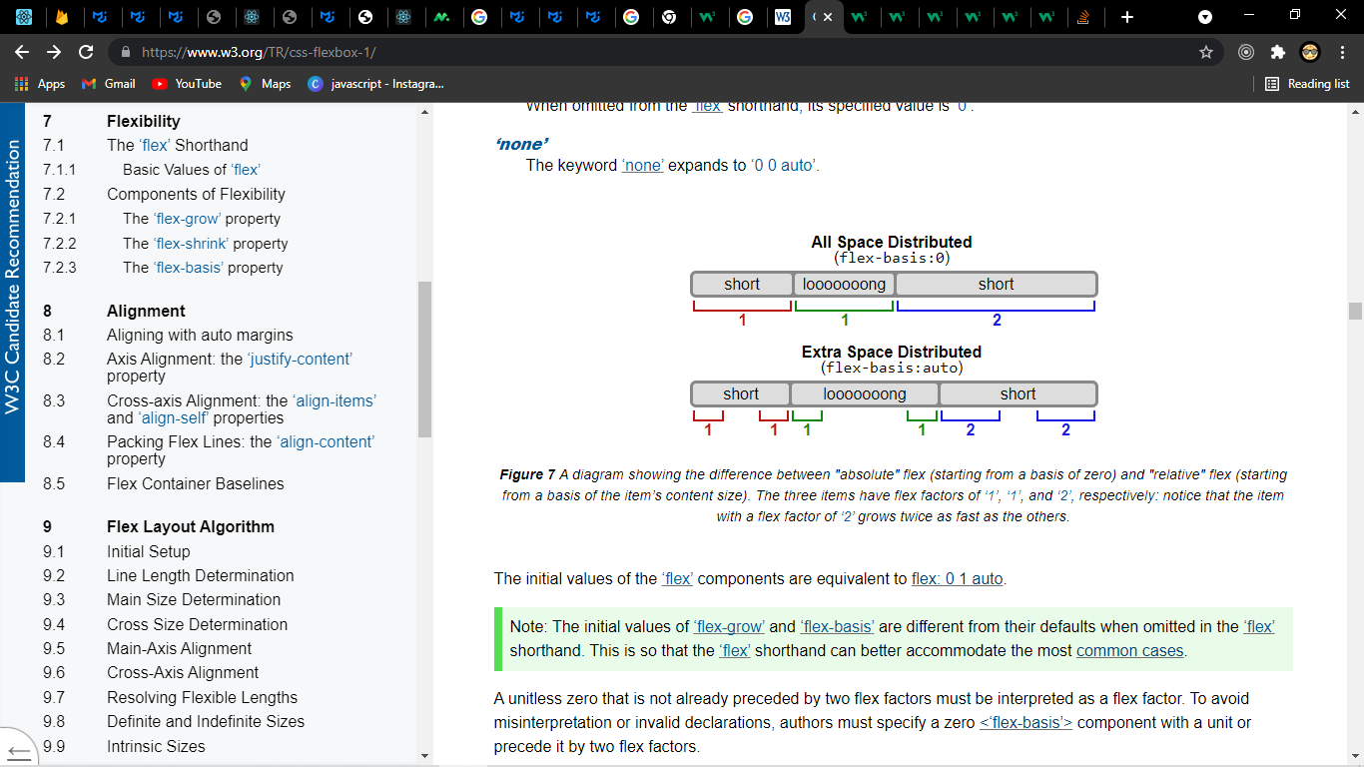

The initial values of the flex components are equivalent to flex: 0 1 auto.
The initial values of flex-grow and flex-basis are different from their defaults when omitted in the flex shorthand. This is so that the flex shorthand can better accommodate the most common cases.

Flex-basis doesn't always apply to width.
When flex-direction is row, flex-basis controls width.
But when flex-direction is column, flex-basis controls height.

Key Differences
Here are some important differences between flex-basis and width / height:
flex-basis applies only to flex items. Flex containers (that aren't also flex items) will ignore flex-basis but can use width and height.
flex-basis works only on the main axis. For example, if you're in flex-direction: column, the width property would be needed for sizing flex items horizontally.
flex-basis has no effect on absolutely-positioned flex items. width and height properties would be necessary. Absolutely-positioned flex items do not participate in flex layout.
By using the flex property, three properties – flex-grow, flex-shrink and flex-basis – can be neatly combined into one declaration. Using width, the same rule would require multiple lines of code.

Basic Values of flex

The list below summarizes the effects of the four flex values that represent most commonly-desired effects:

flex: initial
Equivalent to flex: 0 1 auto. (This is the initial value.) Sizes the item based on the width/height properties. (If the item’s main size property computes to auto, this will size the flex item based on its contents.) Makes the flex item inflexible when there is positive free space, but allows it to shrink to its minimum size when there is insufficient space. The alignment abilities or auto margins can be used to align flex items along the main axis.

flex: auto
Equivalent to flex: 1 1 auto. Sizes the item based on the width/height properties, but makes them fully flexible, so that they absorb any free space along the main axis. If all items are either flex: auto, flex: initial, or flex: none, any positive free space after the items have been sized will be distributed evenly to the items with flex: auto.

flex: none
Equivalent to flex: 0 0 auto. This value sizes the item according to the width/height properties, but makes the flex item fully inflexible. This is similar to initial, except that flex items are not allowed to shrink, even in overflow situations.

flex: <positive-number>
Equivalent to flex: <positive-number> 1 0. Makes the flex item flexible and sets the flex basis to zero, resulting in an item that receives the specified proportion of the free space in the flex container. If all items in the flex container use this pattern, their sizes will be proportional to the specified flex factor.
By default, flex items won’t shrink below their minimum content size (the length of the longest word or fixed-size element). To change this, set the min-width or min-height property.

The flex-grow property

Name: | flex-grow
Value: | <number>
Initial: | 0
Applies to: | flex items
Inherited: | no
Percentages: | n/a
Computed value: | specified number
Canonical order: | per grammar
Animation type: | by computed value type
Authors are encouraged to control flexibility using the flex shorthand rather than with flex-grow directly, as the shorthand correctly resets any unspecified components to accommodate common uses.
The flex-grow property sets the flex grow factor to the provided <number>. Negative numbers are invalid.

The flex-shrink property

Name: | flex-shrink
Value: | <number>
Initial: | 1
Applies to: | flex items
Inherited: | no
Percentages: | n/a
Computed value: | specified value
Canonical order: | per grammar
Animation type: | number
Authors are encouraged to control flexibility using the flex shorthand rather than with flex-shrink directly, as the shorthand correctly resets any unspecified components to accommodate common uses.
The flex-shrink property sets the flex shrink factor to the provided <number>. Negative numbers are invalid.

The flex-basis property
Name: | flex-basis
Value: | content | <‘width’>
Initial: | auto
Applies to: | flex items
Inherited: | no
Percentages: | relative to the flex container’s inner main size
Computed value: | specified keyword or a computed <length-percentage> value
Canonical order: | per grammar
Animation type: | by computed value type
Authors are encouraged to control flexibility using the flex shorthand rather than with flex-basis directly, as the shorthand correctly resets any unspecified components to accommodate common uses.
The flex-basis property sets the flex basis. It accepts the same values as the width and height property, plus content.

For all values other than auto and content (defined above), flex-basis is resolved the same way as width in horizontal writing modes [CSS21], except that if a value would resolve to auto for width, it instead resolves to content for flex-basis. For example, percentage values of flex-basis are resolved against the flex item’s containing block (i.e. its flex container); and if that containing block’s size is indefinite, the used value for flex-basis is content. As another corollary, flex-basis determines the size of the content box, unless otherwise specified such as by box-sizing [CSS3UI].

Alignment
After a flex container’s contents have finished their flexing and the dimensions of all flex items are finalized, they can then be aligned within the flex container.

The margin properties can be used to align items in a manner similar to, but more powerful than, what margins can do in block layout. Flex items also respect the alignment properties from CSS Box Alignment, which allow easy keyword-based alignment of items in both the main axis and cross axis.

Aligning with auto margins

Auto margins on flex items have an effect very similar to auto margins in block flow:
During calculations of flex bases and flexible lengths, auto margins are treated as 0.

Prior to alignment via justify-content and align-self, any positive free space is distributed to auto margins in that dimension.
Overflowing boxes ignore their auto margins and overflow in the end direction.
If free space is distributed to auto margins, the alignment properties will have no effect in that dimension because the margins will have stolen all the free space left over after flexing.

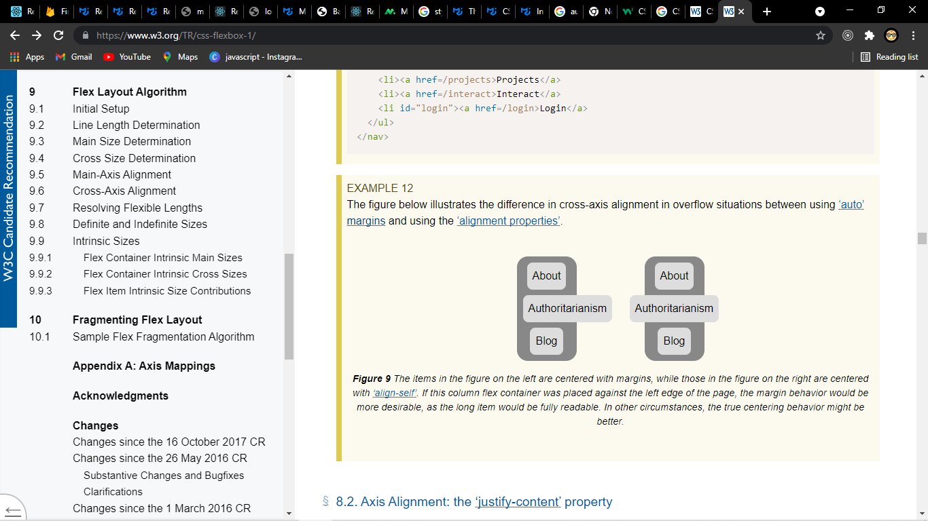

Axis Alignment: the justify-content property
Name: | justify-content
Value: | flex-start | flex-end | center | space-between | space-around
Initial: | flex-start
Applies to: | flex containers
Inherited: | no
Percentages: | n/a
Computed value: | specified keyword
Canonical order: | per grammar
Animation type: | discrete

The justify-content property aligns flex items along the main axis of the current line of the flex container. This is done after any flexible lengths and any auto margins have been resolved. Typically it helps distribute extra free space leftover when either all the flex items on a line are inflexible, or are flexible but have reached their maximum size. It also exerts some control over the alignment of items when they overflow the line.

flex-start
Flex items are packed toward the start of the line. The main-start margin edge of the first flex item on the line is placed flush with the main-start edge of the line, and each subsequent flex item is placed flush with the preceding item.

flex-end
Flex items are packed toward the end of the line. The main-end margin edge of the last flex item is placed flush with the main-end edge of the line, and each preceding flex item is placed flush with the subsequent item.

center
Flex items are packed toward the center of the line. The flex items on the line are placed flush with each other and aligned in the center of the line, with equal amounts of space between the main-start edge of the line and the first item on the line and between the main-end edge of the line and the last item on the line. (If the leftover free-space is negative, the flex items will overflow equally in both directions.)

space-between
Flex items are evenly distributed in the line. If the leftover free-space is negative or there is only a single flex item on the line, this value is identical to flex-start. Otherwise, the main-start margin edge of the first flex item on the line is placed flush with the main-start edge of the line, the main-end margin edge of the last flex item on the line is placed flush with the main-end edge of the line, and the remaining flex items on the line are distributed so that the spacing between any two adjacent items is the same.

space-around
Flex items are evenly distributed in the line, with half-size spaces on either end. If the leftover free-space is negative or there is only a single flex item on the line, this value is identical to center. Otherwise, the flex items on the line are distributed such that the spacing between any two adjacent flex items on the line is the same, and the spacing between the first/last flex items and the flex container edges is half the size of the spacing between flex items.

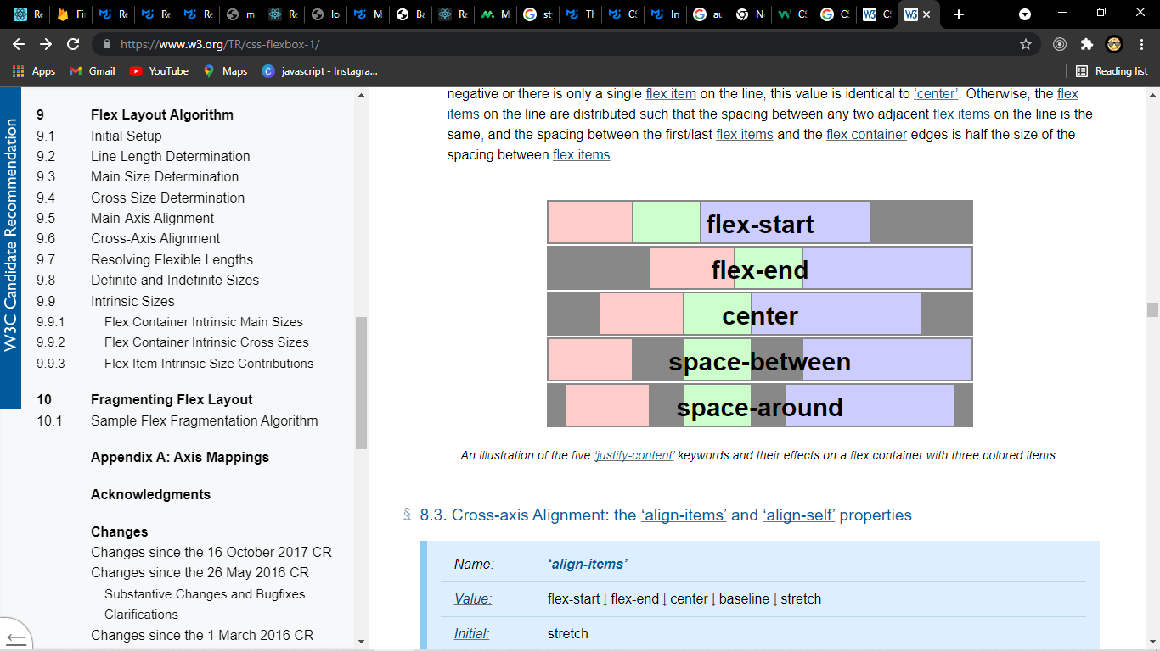

Cross-axis Alignment: the align-items and align-self properties

Name: | align-items
Value: | flex-start | flex-end | center | baseline | stretch
Initial: | stretch
Applies to: | flex containers
Inherited: | no
Percentages: | n/a
Computed value: | specified keyword
Canonical order: | per grammar
Animation type: | discrete

Name: | align-self
Value: | auto | flex-start | flex-end | center | baseline | stretch
Initial: | auto
Applies to: | flex items
Inherited: | no
Percentages: | n/a
Computed value: | specified keyword
Canonical order: | per grammar
Animation type: | discrete

Flex items can be aligned in the cross axis of the current line of the flex container, similar to justify-content but in the perpendicular direction. align-items sets the default alignment for all of the flex container’s items, including anonymous flex items. align-self allows this default alignment to be overridden for individual flex items. (For anonymous flex items, align-self always matches the value of align-items on their associated flex container.)

If either of the flex item’s cross-axis margins are auto, align-self has no effect.

Values have the following meanings:

auto
Defers cross-axis alignment control to the value of align-items on the parent box. (This is the initial value of align-self.)

flex-start
The cross-start margin edge of the flex item is placed flush with the cross-start edge of the line.

flex-end
The cross-end margin edge of the flex item is placed flush with the cross-end edge of the line.

center
The flex item’s margin box is centered in the cross axis within the line. (If the cross size of the flex line is less than that of the flex item, it will overflow equally in both directions.)

baseline
The flex item participates in baseline alignment: all participating flex items on the line are aligned such that their baselines align, and the item with the largest distance between its baseline and its cross-start margin edge is placed flush against the cross-start edge of the line. If the item does not have a baseline in the necessary axis, then one is synthesized from the flex item’s border box.
In short items are aligned such as their baselines align

stretch
If the cross size property of the flex item computes to auto, and neither of the cross-axis margins are auto, the flex item is stretched. Its used value is the length necessary to make the cross size of the item’s margin box as close to the same size as the line as possible, while still respecting the constraints imposed by min-height/min-width/max-height/max-width.

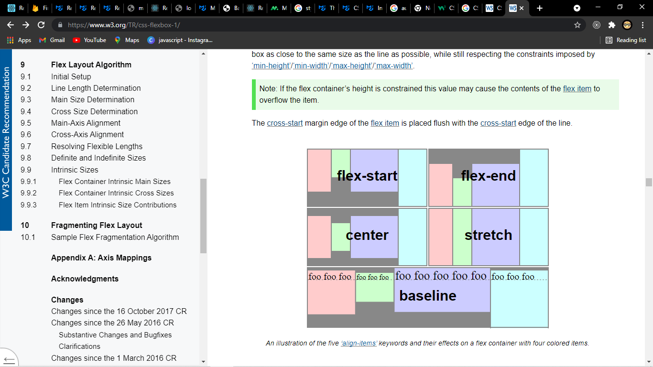

Packing Flex Lines: the align-content property
Name: | align-content
Value: | flex-start | flex-end | center | space-between | space-around | stretch
Initial: | stretch
Applies to: | multi-line flex containers
Inherited: | no
Percentages: | n/a
Computed value: | specified keyword
Canonical order: | per grammar
Animation type: | discrete

The align-content property aligns a flex container’s lines within the flex container when there is extra space in the cross-axis, similar to how justify-content aligns individual items within the main-axis. Note, this property has no effect on a single-line flex container. Values have the following meanings:
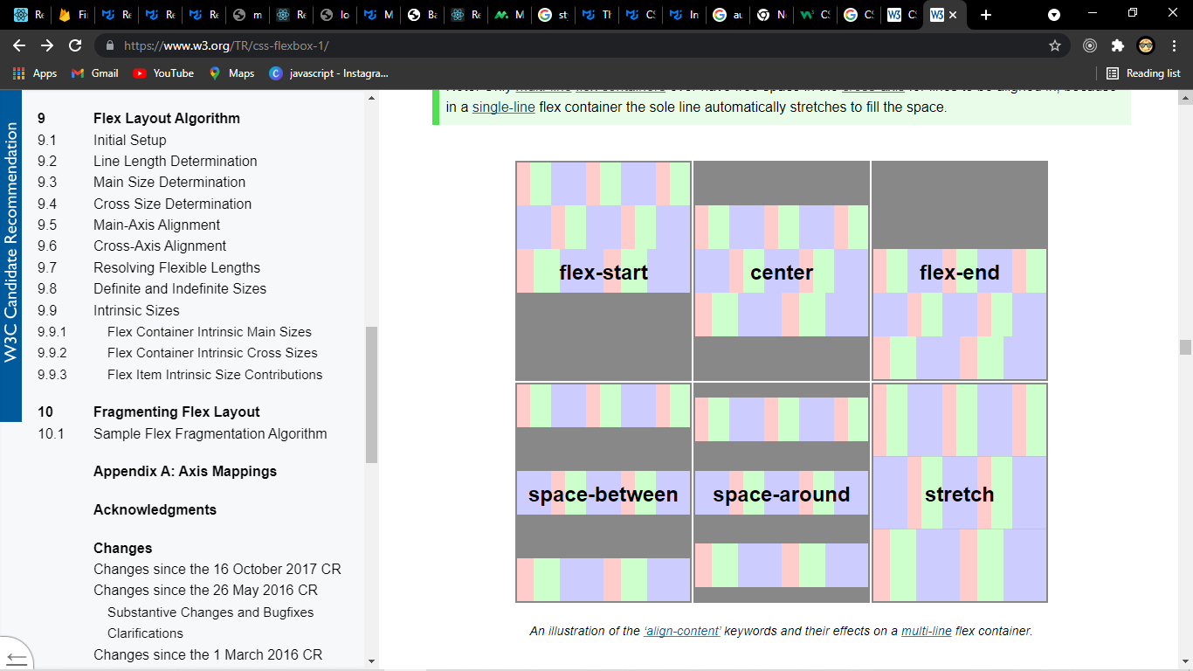
flex-start
Lines are packed toward the start of the flex container. The cross-start edge of the first line in the flex container is placed flush with the cross-start edge of the flex container, and each subsequent line is placed flush with the preceding line.
flex-end
Lines are packed toward the end of the flex container. The cross-end edge of the last line is placed flush with the cross-end edge of the flex container, and each preceding line is placed flush with the subsequent line.
center
Lines are packed toward the center of the flex container. The lines in the flex container are placed flush with each other and aligned in the center of the flex container, with equal amounts of space between the cross-start content edge of the flex container and the first line in the flex container, and between the cross-end content edge of the flex container and the last line in the flex container. (If the leftover free-space is negative, the lines will overflow equally in both directions.)
space-between
Lines are evenly distributed in the flex container. If the leftover free-space is negative or there is only a single flex line in the flex container, this value is identical to flex-start. Otherwise, the cross-start edge of the first line in the flex container is placed flush with the cross-start content edge of the flex container, the cross-end edge of the last line in the flex container is placed flush with the cross-end content edge of the flex container, and the remaining lines in the flex container are distributed so that the spacing between any two adjacent lines is the same.
space-around
Lines are evenly distributed in the flex container, with half-size spaces on either end. If the leftover free-space is negative this value is identical to center. Otherwise, the lines in the flex container are distributed such that the spacing between any two adjacent lines is the same, and the spacing between the first/last lines and the flex container edges is half the size of the spacing between flex lines.
stretch
Lines stretch to take up the remaining space. If the leftover free-space is negative, this value is identical to flex-start. Otherwise, the free-space is split equally between all of the lines, increasing their cross size.

Flex Container Baselines
In order for a flex container to itself participate in baseline alignment (e.g. when the flex container is itself a flex item in an outer flex container), it needs to submit the position of the baselines that will best represent its contents. To this end, the baselines of a flex container are determined as follows (after reordering with order, and taking flex-direction into account):

first/last main-axis baseline set
When the inline axis of the flex container matches its main axis, its baselines are determined as follows:
If any of the flex items on the flex container’s startmost/endmost flex line participate in baseline alignment, the flex container’s first/last main-axis baseline set is generated from the shared alignment baseline of those flex items.

Otherwise, if the flex container has at least one flex item, the flex container’s first/last main-axis baseline set is generated from the alignment baseline of the startmost/endmost flex item. (If that item has no alignment baseline parallel to the flex container’s main axis, then one is first synthesized from its border edges.)

Otherwise, the flex container has no first/last main-axis baseline set, and one is synthesized if needed according to the rules of its alignment context.

first/last cross-axis baseline set
When the inline axis of the flex container matches its cross axis, its baselines are determined as follows:
If the flex container has at least one flex item, the flex container’s first/last cross-axis baseline set is generated from the alignment baseline of the startmost/endmost flex item. (If that item has no alignment baseline parallel to the flex container’s cross axis, then one is first synthesized from its border edges.)

Otherwise, the flex container has no first/last cross-axis baseline set, and one is synthesized if needed according to the rules of its alignment context.

When calculating the baseline according to the above rules, if the box contributing a baseline has an overflow value that allows scrolling, the box must be treated as being in its initial scroll position for the purpose of determining its baseline.

